Chapter1 What is a computer

What is a computer?

* A computer is an electronic machine that performs operations and a set of operations is a program.
* A hardware is a physical part of computer.

Desktop laptop

* Case Screen
* Keyboard key board
* Mouse touch pad
* Screen

1. A power button use when we want to turn on computer.
2. Lock screen (Window + L)
3. Login screen Ctrl +Alt + Delete +log

Change Your Password

* Enter the magic keys Ctrl +Alt + Delete
* Select change a password

Change password

A Mouse Can Perform 5 Actions

* Action Usage
* Left Select objects
* Right click Open pop-up menus
* Double(left)click Open file, application
* Drag Move the select object
* Scroll Scroll on a document

S2 Work on Windows

1. What is an operating system?

* An operating system is a program that allow to intect with your computer.

1. When was the first window Operating system created?

* The first window operating system created in 1985.

1. Now which version of window are we using?

* Now we are using window 10.
* How to use window desktop?

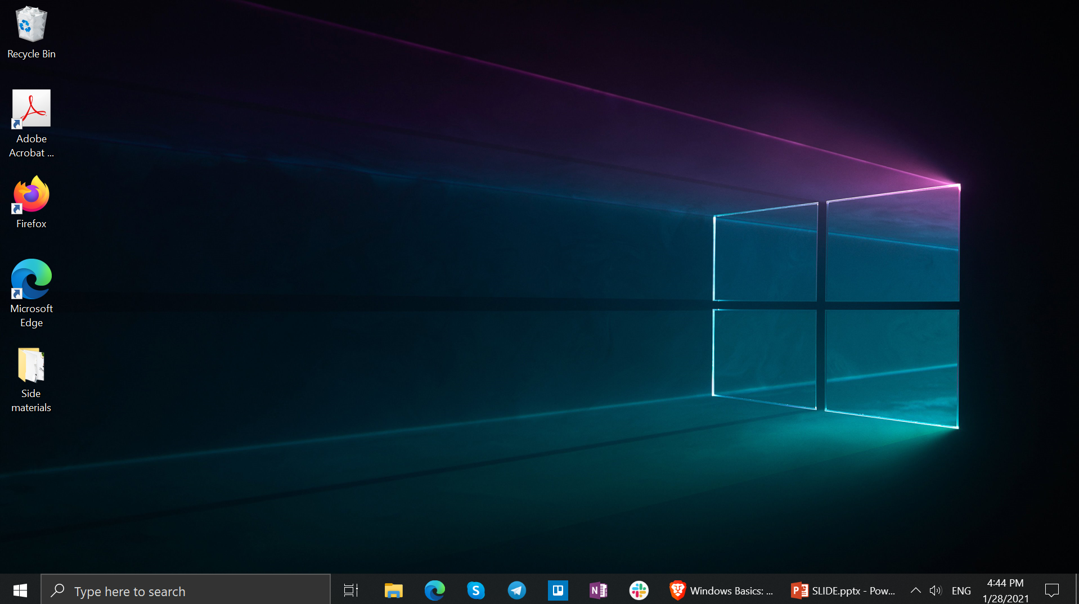

Start Menu

Recycle Bin

Application Icons

Taskbar

Desktop Background

Folder on desktop

***The Desktop***

* How to use window start menu and taskbar?
* On the canter or left of the taskbar, select the start icons.
* Press the window logo key on your keyboard.
* Swipe up from the button center or left of your screen.
* What is an **application**?
* An application is a software that allows you to **complete tasks**on your computer